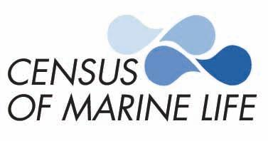

EMBARGO:
5 p.m. GMT / 1 p.m. EDT
Sunday, Oct. 23, 2005
www.coml.org
COML History of Marine Animal Populations Project
“Oceans Past” Open Science Conference
24-27 October 2005, Kolding, Denmark

Contacts: Terry Collins, CoML, +1-416-878-8712; +1-416-538-8712; terrycollins@rogers.com
Anne Marboe, HMAP (Denmark), +45 6550 41 49; ahm@hist.sdu.dk
Darlene Trew Crist, +1-401-295-1356, Sara Hickox, +1-401-874-6277

Texas A&M researcher Glenn A. Jones, HMAP project leader Poul Holm and other CoML experts are available Thurs.-Fri. Oct. 20-21 for advance interviews. Please call contacts or email terrycollins@rogers.com to schedule a time. High-resolution images are available for media download at http://www.coml.org/embargo/embargo7.htm

Restaurant Seafood Prices Since 1850s
Help Plot Marine Harvests Through History

100 Ocean Historians, Scientists to Meet in Denmark Oct. 24-27
History of North Sea Stocks Offers New Insights on Modern Policies

Seafood prices collected from U.S. restaurant menus dating to the 1850s will help plot the shifting harvest of marine species, according to a study to be announced at Oceans Past a Census of Marine Life conference in Denmark on the History of Marine Animal Populations.

Led by paleo-oceanographer Glenn Jones at Texas A&M University in Galveston, researchers are charting over 150 years of inflation-adjusted seafood prices from menus, most from cities such as New York, Boston, San Francisco and Providence. The menus shed light on shifting tastes for and supplies of such popular seafood as lobster, swordfish, abalone, oysters, halibut, haddock and sole.

Though still at an early stage, the research already shows a dramatic rise in the price of abalone coincident with the collapse of stocks along the California coast.

San Francisco menus, which started to feature the slow-growing mollusk in the 1920s, document that the inflation-adjusted price of an abalone meal held steady at about $7 (in 2004 currency) for roughly 20 years.
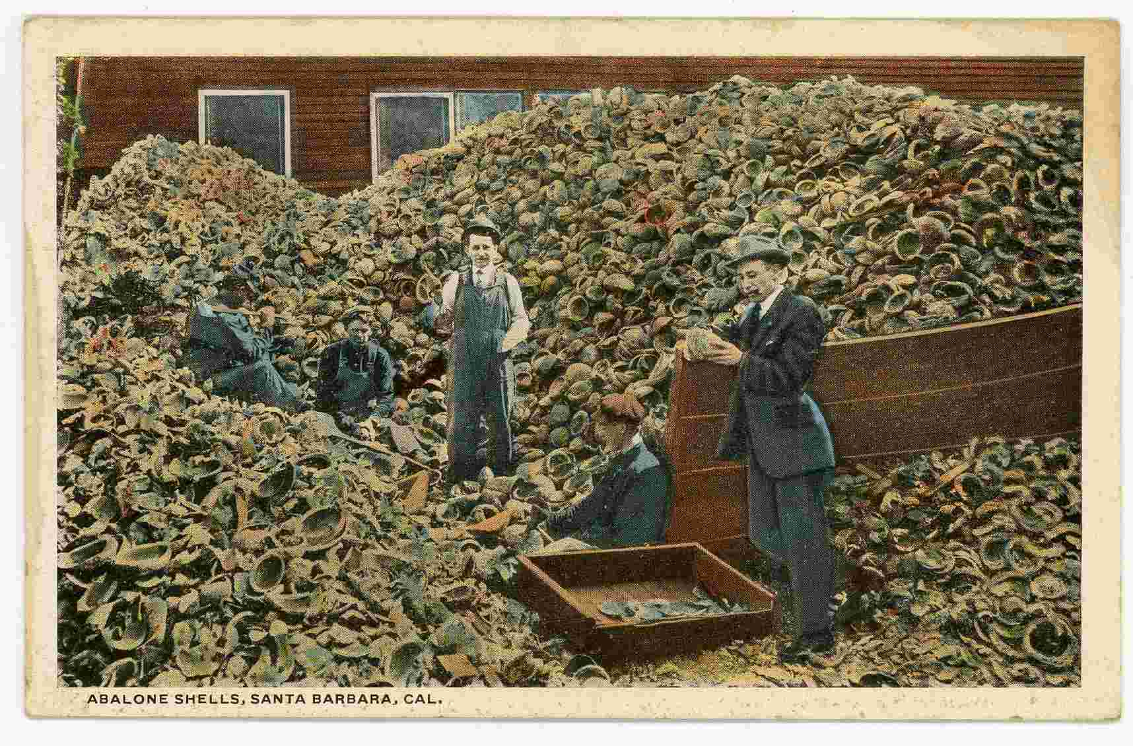
The price spiked sharply in the 1930s as the species was over-harvested and again in the 1950s, since which time the price has risen 7 to 10 times faster than inflation. California banned commercial abalone fishing in 1997 and most supplies in state restaurants today are imported from Australia and New Zealand, priced on menus at $50 to $70.
A hill of Abalone shells, Santa Barbara, California, circa 1920. This image and others are available in high-resolution at http://www.coml.org/embargo/embargo7.htm
Similarly, the restaurant price of lobster has tracked its fluctuating abundance and popularity over the decades, according to Dr. Jones.

“Prior to the 1880s, it was unusual to see lobster on menus at all except in bargain-priced lobster salad,” he says. “It was considered a trash fish no one wanted -- it was not something you'd want to be seen eating. In fact, in Colonial America, servants negotiated agreements that they not be forced to eat lobster more than twice a week.”

Tastes started to change in the 1880s, with lobsters even appearing on menu covers. The 1930s saw prices fall with the Great Depression, but they ballooned in the 1950s, with restaurants pricing lobsters at one-quarter pound (113 gram) weight increments, another reflection of declining supplies, says Dr. Jones.

“It’s interesting on menus today to see the appearance of four and five pound (1.8 to 2.3 kilo) lobsters,” he notes. “There is little chance those are coming from the inshore fisheries, which are so heavily fished a lobster is sent to market as soon as it’s up to weight. What it indicates to me is the opening up of new deep areas on the outer continental shelf, 200 miles (322 km) offshore.”

Among other observations gained from the archived menus: oyster prices remained relatively flat for some 100 years, then climbed at twice the inflation rate starting in the 1950s.

And the price of a wild canvasback duck meal rose from today’s equivalent of $20 in the 1860s to $100 in 1910 as stocks collapsed. Professional hunters harvested up to 1,000 per day to supply restaurants, says Dr. Jones, fostering the federal government’s decision to outlaw the commercial slaughter of migratory birds in 1913.

“As supplies dropped and prices rose, some of these species became a status symbol. It seems to confirm that many people simply want to eat something that is rare.”
Some 200,000 restaurant menus have been uncovered by the research team in various archives, primarily in New England. Of these, many are banquet menus showing only the food served; Dr. Jones estimates just 10,000 include the date, city and prices.

Yet to be done is a sorting of five-star versus two-star restaurants, which Dr. Jones says will narrow the price spread in a given year but will not diminish the trends seen overall (plotted on several preliminary charts, appended).

“When you think about it, a menu was a piece of ephemera it wasn't meant to be saved but thankfully some people collected them. We believe this is the first time anyone has tried to work with this trove of historical information.”

The History of Marine Animal Populations “Oceans Past” Conference

More than 100 marine biologists, ecologists, historians and other scientists from 25 countries will attend the conference to discuss discoveries about the bounty of the world's oceans over 500 years and the changes they have undergone.
Extensive and previously unexplored historical and environmental archives provide valuable information and insight into the sometimes startling changes in marine communities along ocean shorelines and in the open seas. By extending trends backward from the baseline of the present, HMAP’s unearthed records from fossils to fish taxes give a head start to detecting and managing future trends.
The “Oceans Past Conference,” organized by The History of Marine Animal Populations (HMAP) project component of the Census of Marine Life, will probe how the diversity, distribution and abundance of marine life in the world's oceans has changed and the role humans have played in this dynamic process.
More than 75 presentations at the conference will add greatly to what is known about ocean life in the past, and delineate what is unknown but discoverable, and what may be unknowable about the world's oceans.
Fish: Food for all Ages

“Fish has been part of peoples' diets since humans first walked the earth and remains a vital item in the daily diet of millions worldwide,” says Danish environmental historian Poul Holm, who leads the HMAP network of researchers and institutions.
“The Romans ate fish in vast quantities. And over-fishing in medieval Europe was a very real problem in the days of William the Conqueror and Leonardo da Vinci.”
However, the HMAP project is not all about "doom and gloom" and depleted fishing areas, he says. “We stress an understanding of the forces behind the changes.”
With respect to the North Sea, for example, researchers at the conference will show:

- How large harvests of the ling fish prior to 1914 allowed cod to dominate the North Sea, causing ecologists today to rethink models of the North Sea ecosystem;
- How cod stocks in the North Sea have declined in numbers and size based on records dating from the 1870s – illuminating details of productivity in the North Sea 130 years ago;
- How archaeologists are documenting the diminishing size of North Sea fish between the years 1000 and 1500, a sure sign of over-fishing, but that such pressure on stocks was temporary. Even the most exploited species like cod and herring demonstrated ability to recover over time, with lessons for the recovery of such fishing grounds as the Gulf of Maine and Newfoundland, prolific until comparatively recently.
Other research to be showcased at the conference describes:
- How Imperial Rome developed a fish processing industry by smoking, drying, salting and using oil and different sauces to preserve fish. Their techniques spread outside the Empire and into the Northern Black Sea region, where large salting operations in the Crimea became a flourishing industry. A fish soup produced in huge open-air boileries was consumed in such large quantities by the Romans that they significantly reduced fish stocks in the Mediterranean;
- How 600 year-old Queen Conch shells from the Caribbean Sea reveal the decline in average size and age at harvest;
- The decline of coastal seas and estuaries in Europe, North America and Australia within 200-300 years of the intensification of fishing;
- Why the mighty Atlantic bluefin tuna has vanished from much of the Atlantic, where it once roamed from Brazil to the North Atlantic coasts, and why modern fishing practices and regulations are reducing the likelihood that bluefin tuna will recover;
- How thousands of what were once frighteningly referred to as "sea wolves" (Mediterranean monk seals) that filled river mouths in the 14th century became a critically endangered species in the Atlantic today;
- How fishing regulations imposed 800 years ago in the Baltic Sea reveal local societies' concerns about the effects of over-fishing.

“Ocean historians are creatively mining a host of information sources such as the logs of schooner captains and salt tax collectors to reconstruct amazing and valuable insights into fishing and marine life decades and even centuries ago,” says Jesse Ausubel, CoML project director for the New York-based Alfred P. Sloan Foundation.

“The historical component of the Census is creating a picture of what lived in the oceans before fishing became important, and how these populations have changed since fishing loomed large – a time 50 years ago in some areas, 500 in others, and 1,000 or more in a few,” he says.

“The history of marine animal populations is a blind spot in human knowledge being filled by the combined efforts of historians, paleo-ecologists, and ecosystem modelers. Helping visualize the past, now almost unimaginable richness of the oceans could inspire and influence the way marine resources are managed in future.”

For more conference information, including media registration, click here.

The History of Marine Animal Populations (HMAP)
The History of Marine Animal Populations program, part of the Census of Marine Life, aims to improve understanding of ecosystem dynamics, specifically long-term changes in stock abundance, the ecological impact of large-scale harvesting by man, and the role of marine resources in the historical development of human society.
Census of Marine Life
More than 1,700 scientists from 73 countries are at work on the Census, designed to assess the diversity, distribution and abundance of ocean life and explain how it changes over time. The scientists, their institutions and government agencies are pooling their findings to create a comprehensive and authoritative portrait of life in the oceans today, yesterday and tomorrow.

Support for the Census of Marine Life comes from government agencies concerned with science, environment, and fisheries in a growing list of nations as well as from private foundations and companies. The Census is associated or affiliated with several intergovernmental international organizations including the Intergovernmental Oceanographic Commission of the UN, the Food and Agriculture Organization of the UN, the UN Environment Programme and its World Conservation Monitoring Centre, the Global Biodiversity Information Facility, the International Council for the Exploration of the Seas, and the North Pacific Marine Science Organization. It is also affiliated with international nongovernmental organizations including the Scientific Committee on Oceanic Research and the International Association of Biological Oceanography of the International Council for Science. The Census is led by an independently constituted international Scientific Steering Committee, whose members serve in their individual capacities, and a growing set of national and regional implementation committees.
Appendix:
Restaurant menu prices of various species (inflation-adjusted)
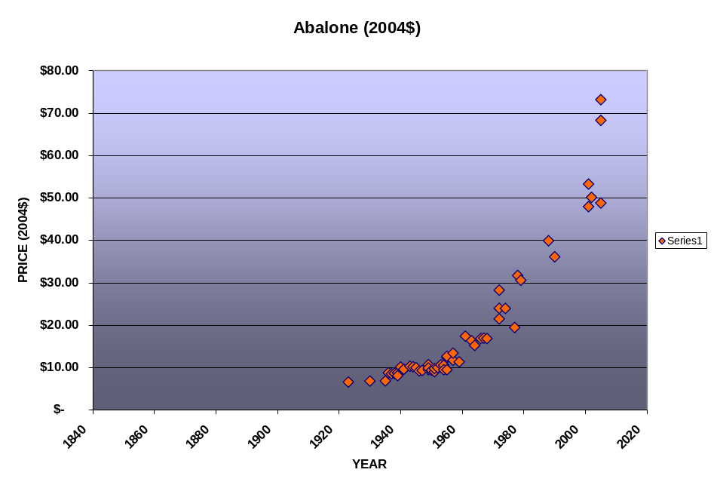
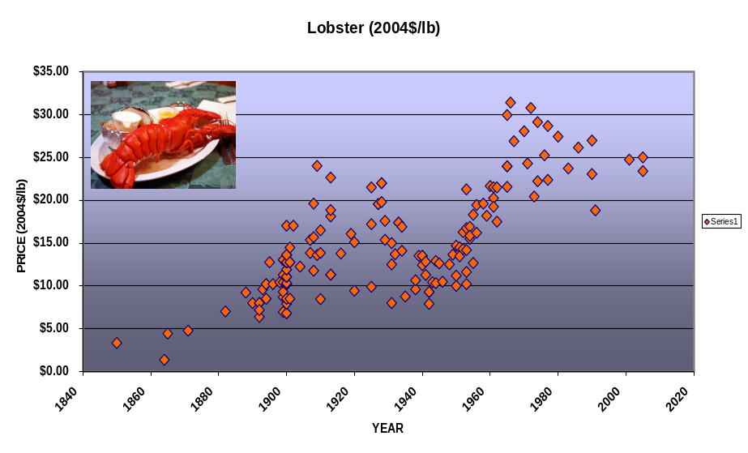
Above: the price of abalone in San Francisco restaurants. Abalone does not appear on menus examined to date from the 1870’s to the early 1920’s. From the early 1920’s to the late 1930’s the price closely tracked the Consumer Price Index (CPI). This inflation-adjusted chart shows prices flat at a 2004 equivalent of about $7.00 until the late 1930’s and a second jump in inflation-adjusted prices in the late 1950’s. Since the late 1950’s the price of abalone has risen 7 to 10 times faster than inflation.

Above: inflation-adjusted price of lobster (normalized to 1 pound). Prior to 1880 lobster meals were rarely offered but lobster salad was common. Prices rise faster than inflation starting in the 1860’s, a trend continued until the mid/late 1920’s. In the 1930’s and 1940’s the inflation-adjusted price fell but from the 1950’s to the 1970’s it again exceeded inflation. In years since then the inflation-adjusted price has remained stable or fallen slightly.
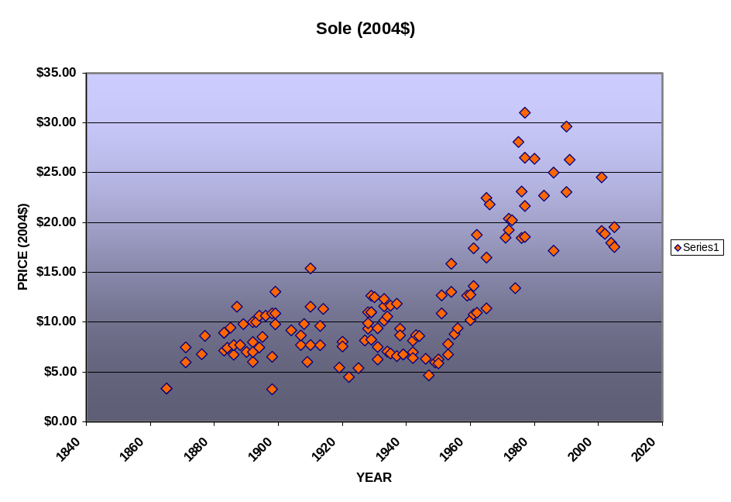
Inflation-adjusted prices of Sole from the 1860’s to today (including the generic Filet of Sole, Lemon Sole and Gray Sole. Does not include Dover/English Sole). Prices closely tracked inflation from the 1860’s to the 1950’s, then rose three times faster than inflation until the early 1980s. Since then inflation-adjusted prices have slightly fallen. 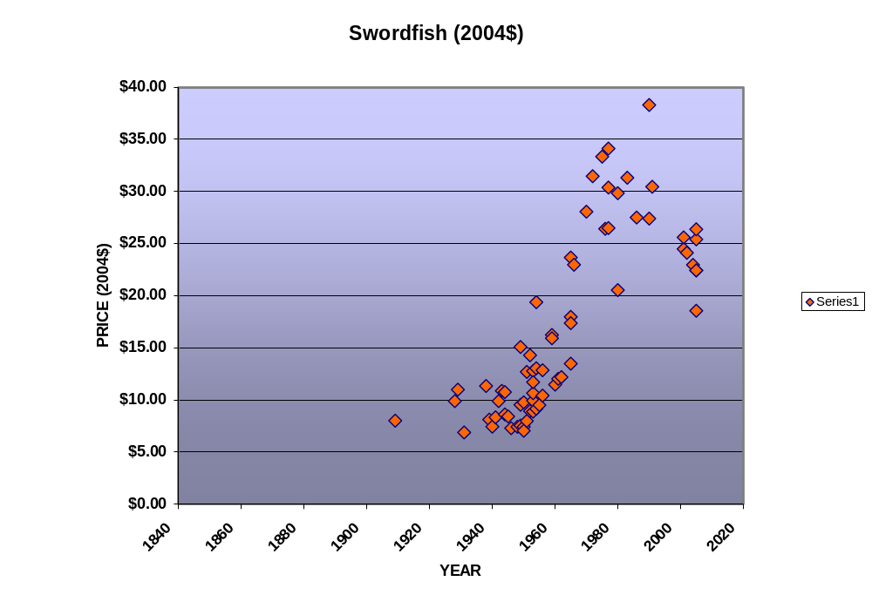
Despite the start of a swordfish fishery in the 1880’s, no restaurant menu entry for swordfish is seen prior to 1909. The large pelagic swordfish had stable inflation-adjusted prices until the mid 1950’s, after which they rose rapidly. Prices rose three times faster than inflation until the late 1970’s, after which they appear to have slightly fallen.

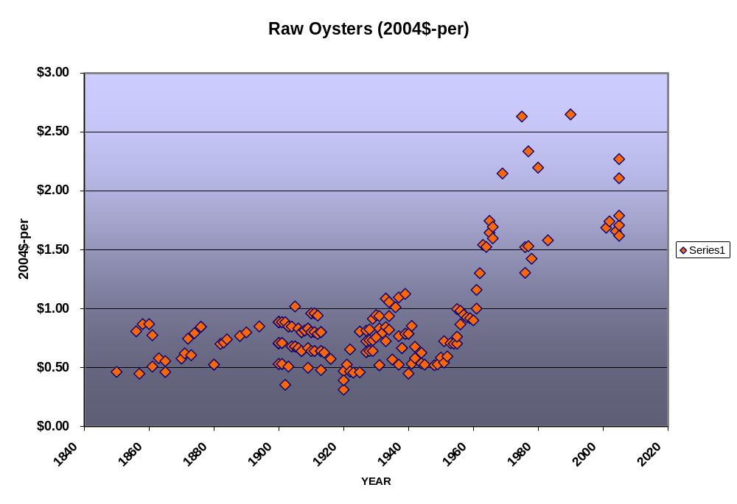
Raw oysters have been popular on restaurant menus for over 150 years. The inflation adjusted prices from New York and Massachusetts restaurant menus very closely track the inflation rate from the 1850’s to the 1950’s, after which they doubled in less than 10 years. Inflation-adjusted prices have been stable for much of the past 40 years.

